Project Design Phase-II
Data Flow Diagram & User Stories

Date | 27 June 2026
Team ID: RH-2026 | RH-2026
Project Name: RentalHouse | RentalHouse
Maximum Marks | 4 Marks

Data Flow Diagrams:
A Data Flow Diagram (DFD) is a traditional visual representation of the information flows within a system. A neat and clear DFD can depict the right amount of the system requirement graphically. It shows how data enters and leaves the system, what changes the information, and where data is stored.
Example: DFD Level 0 (Industry Standard)
RentalHouse Data Flow Diagram (Level 1 - Light Theme):
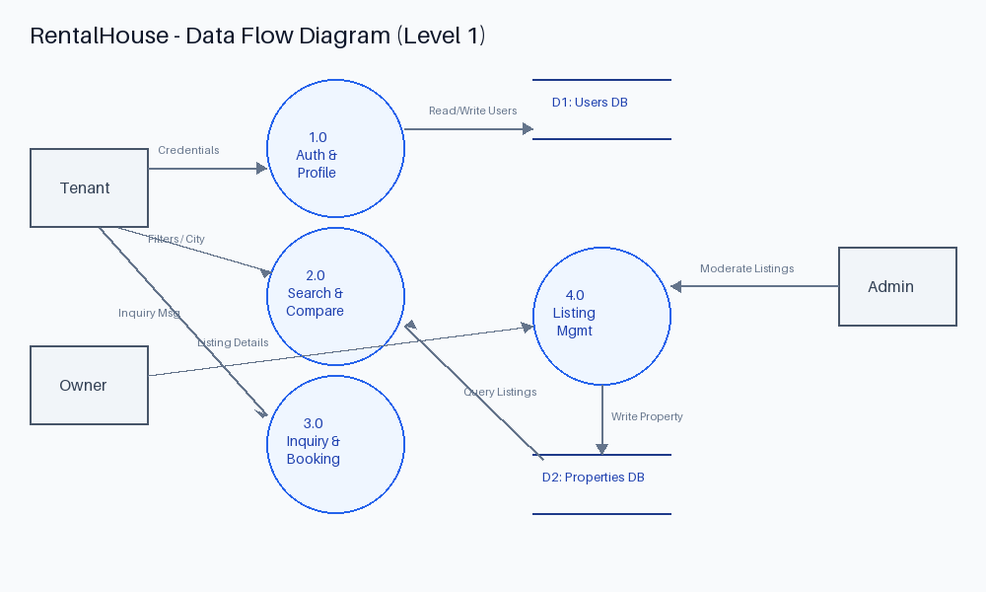


User Stories
Use the below template to list all the user stories for the product.
User Type | Functional Requirement (Epic) | User Story Number | User Story / Task | Acceptance criteria | Priority | Release
Tenant / Owner | Authentication | USN-1 | As a user, I can register for the application by entering name, email, password, and role. | Valid account created in Database. User can now login. | High | Sprint-1
Tenant | Search Catalog | USN-2 | As a tenant, I can search properties by city and filter by rent range, BHK, and amenities. | Only properties matching filters are loaded. Zero listings show helpful empty state. | High | Sprint-2
Tenant | Compare System | USN-3 | As a tenant, I can add up to 3 properties to compare and view side-by-side comparison matrix. | Grid comparison page displays selected listing cards and parameters on one page. | Medium | Sprint-3
Tenant | Booking Request | USN-4 | As a tenant, I can fill an inquiry form on property details to request a visit. | Inquiry logged in owner dashboard inbox and email alert printed to console. | Medium | Sprint-3
Owner | Manage Properties | USN-5 | As an owner, I can add, edit, and delete listings from my custom dashboard. | Owner listings updated in DB. Associated images uploaded to local/cloud folder. | High | Sprint-2
Admin | Administration | USN-6 | As an admin, I can monitor all listings, delete flags, and manage user accounts. | Admin deletes listings or blocks users which immediately updates their active state in DB. | Medium | Sprint-4

